**YOUR FINAL TASK**

**COMPUTER PROGRAMMING 2**

(Week 9)

**NAME: Aidre Love S. Cabrera GRADE & SECTION: 12 – STEM A**

**TEACHER: Antony Pleños DATE SUBMITTED: April 2, 2022**

1. **Instructions:** Write **True** on the blank provided if the statement is correct, otherwise, write **False**.

**False** 1. Classes that help handle errors in Java are called error classes.

**True** 2. It is possible to have several catch blocks following a try block.

**False** 3. A try block does not need to have a matching catch block.

**False** 4. A catch block does not need to have a matching try block.

**True** 5. Several catch statements following a single try statements should handle different exceptions.

**False** 6. The finally statement is required after using try and catch statements.

**True** 7. The block within the finally statement will be executed regardless of whether or not an error is encountered.

**True** 8. The IOException class handles errors that occur during input and output.

**True** 9. The Exception class handle all types of exceptions.

**True** 10. Declaring catch blocks before a block that handles an Exception class to handle other types of errors would be redundant.

1. **Instructions:** Insert the missing keyword to execute code, after try catch, regardless of the result.

**Problem**

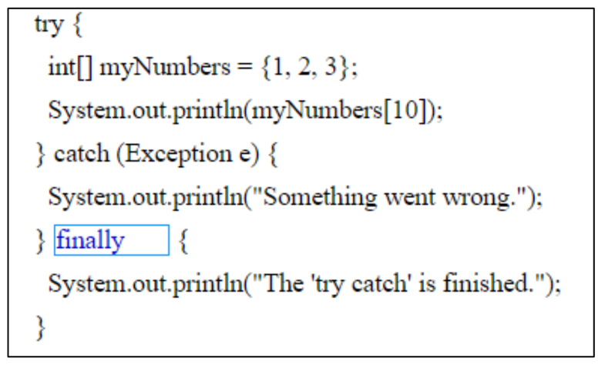

try

myNumbers

catch

finally

**Solution**

**Solution**

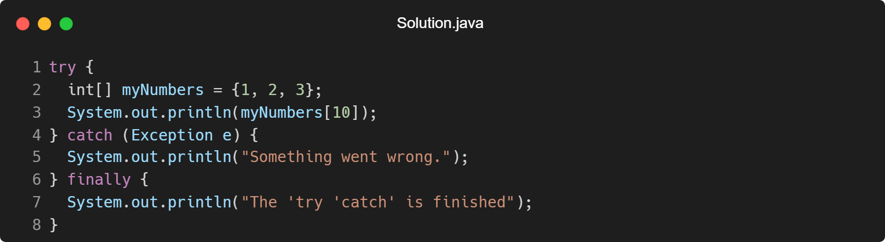

1. **Instructions:** Give the output produced by the following code snippets.
2. int n = 5;

try {

n = n / 0;

}

catch (ArithmeticException e) {

System.out.println(“Arithmetic Exception Caught”);

}

catch (NumberFormatException e) {

System.out.println(“Number Format Exception Caught”);

}

finally {

System.out.println(“Done”)

}

**Answer:**

java: ‘;’ expected; Line #

Realistically, the provided code will result a syntax error. That is because in Line 12, in finally block, the print method has a missing semicolon. Therefore, the output that will be produced when strictly following the provided code snippet will be “java: “expected; Line 11.”

**Proof of Error**

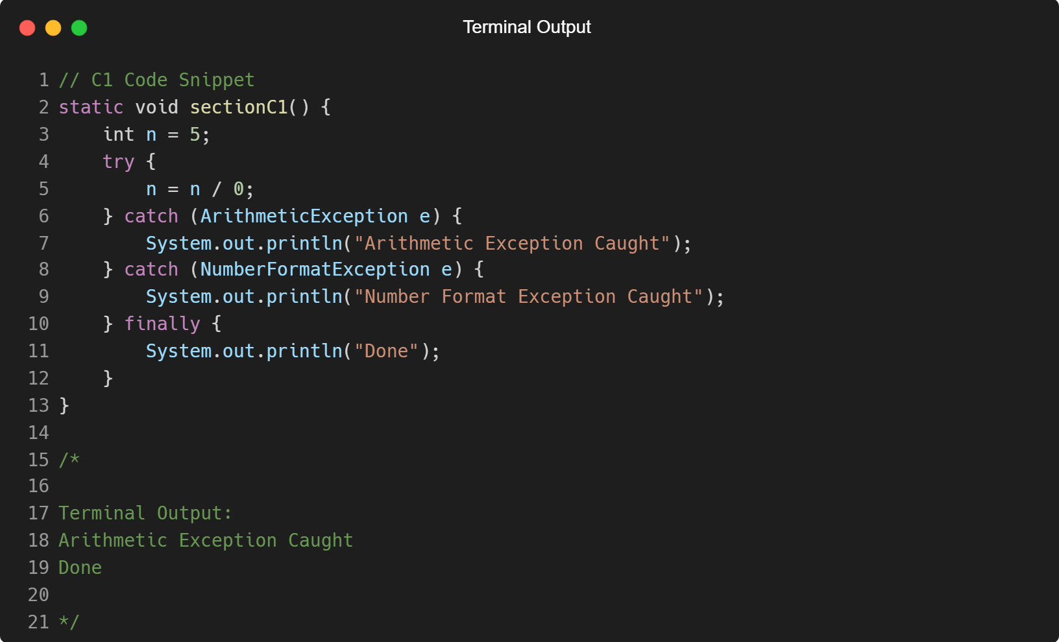

To alleviate the simple error, we can simply add a semicolon before the error line and the output will be:

Arithmetic Exception Caught

Done

**C2 Final Answer and Proof**

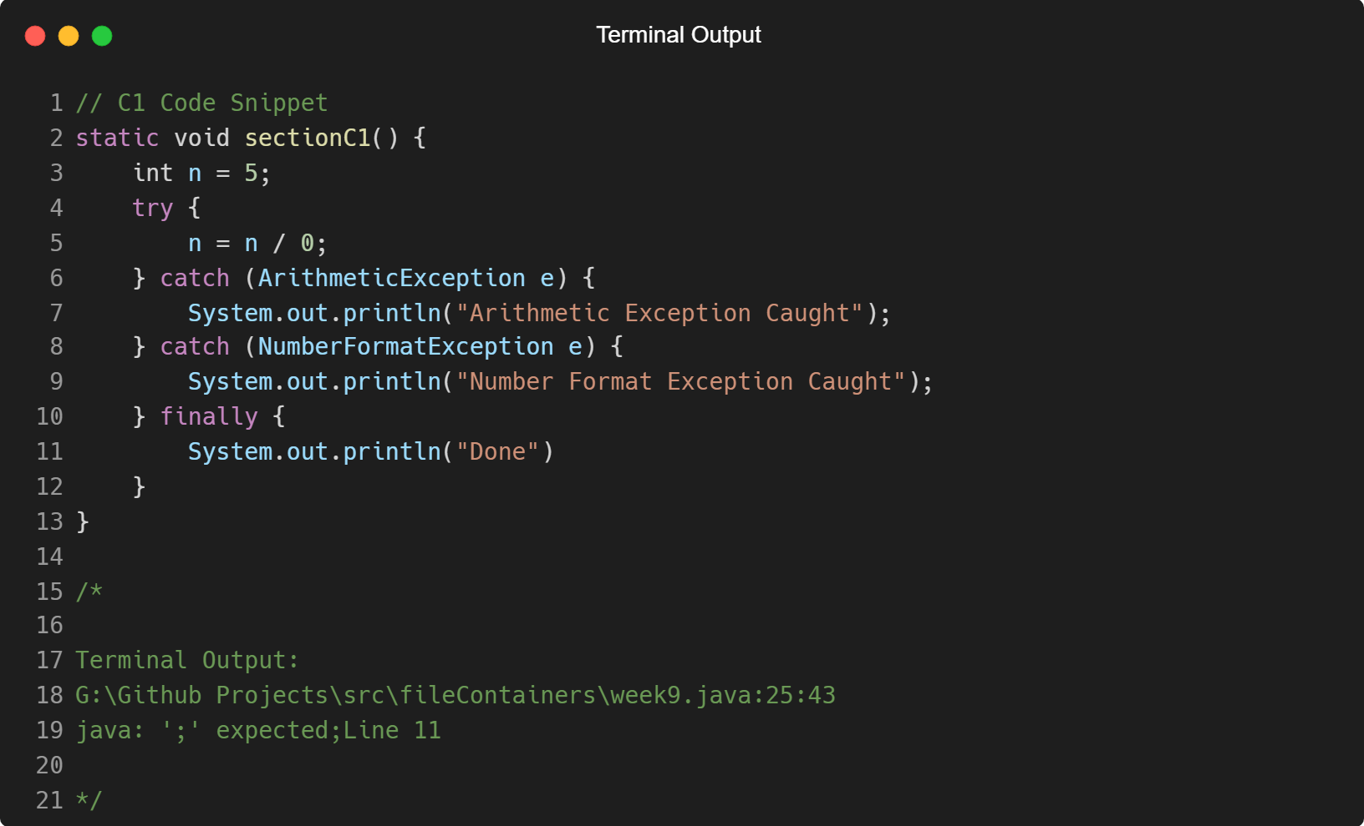

1. int n = 5;

try {

n = n / 0;

}

catch (Exception e) {

System.out.println(“Exception Caught”);

}

finally {

System.out.println(“Done”)

}

**Answer:**

java: ‘;’ expected; Line #

The same error is encountered in this snippet from the previous snippet. However, the solution is the same.

**Proof of Error**

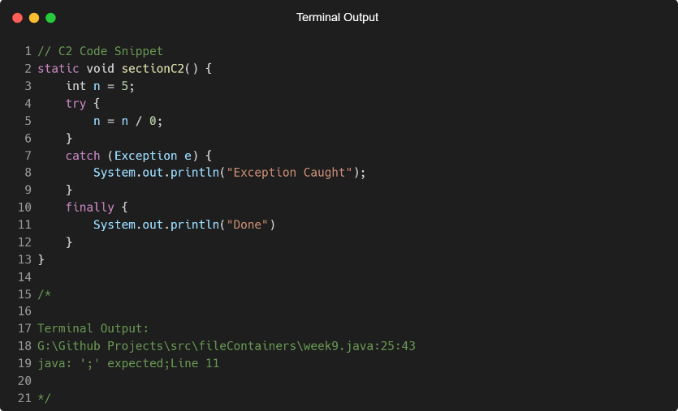

**C2 Final Answer and Proof**

Exception Caught

Done

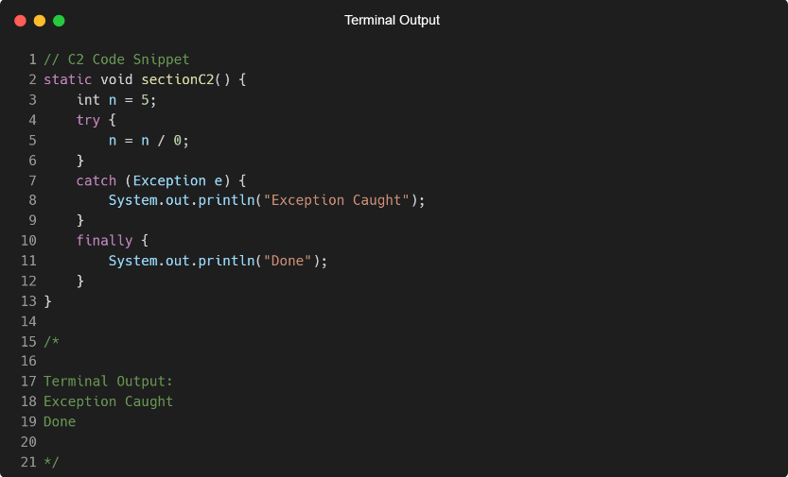

**Appendix I**

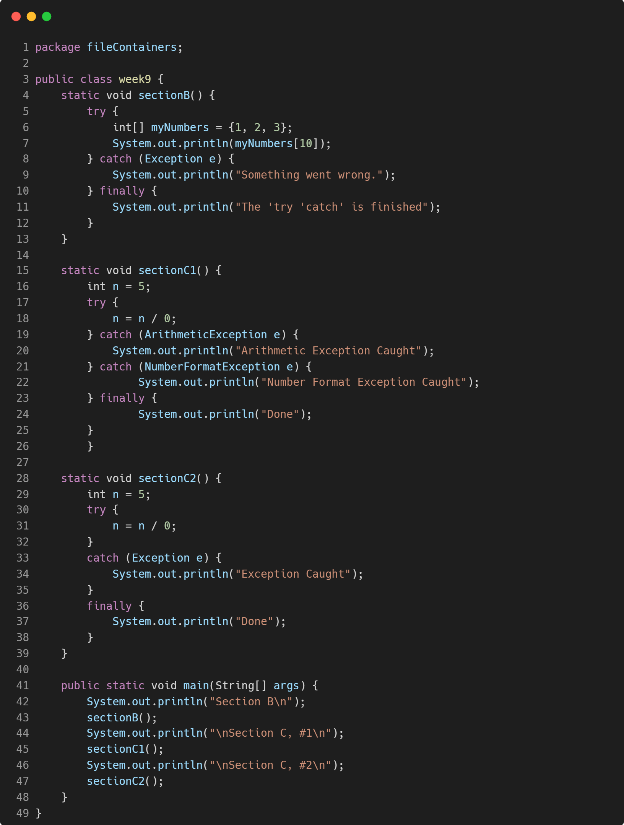

**Appendix II**

